Artificial Intelligence Lab

Lab Manual 6

(Searching Algorithms)



Department of Cyber Security

HITEC University Taxila

Implementation of Uninformed Searching Algorithms

Objective:
- Understand the informed and uninformed searching algorithm
- Implementation of breadth and depth-first search algorithm

Introduction:
In the realm of search algorithms in artificial intelligence, there are two main categories: uninformed search and informed search.

Uninformed Search:
Uninformed search algorithms are those that do not have any additional information about the problem other than the information given in the problem definition. These algorithms explore the search space systematically, without any knowledge of the goal state or the cost associated with reaching it. Examples of uninformed search algorithms include:

- Breadth-First Search (BFS)
- Depth-First Search (DFS)
- Dept-Limit Search (DLS)
- Iterative Deepening Depth-First Search (IDDFS)
- Uniform-Cost Search (UCS)

Breadth-first search (BFS)
Breadth-first search (BFS) is a fundamental algorithm for traversing or searching tree or graph data structures. It starts at a chosen node (often called the "root" node) and explores all of the neighbor nodes at the present depth before moving on to nodes at the next depth level.

Here's a high-level overview of how BFS works:
- Begin with a starting node and enqueue it into a queue.
- Dequeue a node from the queue and mark it as visited.
- Enqueue all of its adjacent nodes that have not yet been visited.
- Repeat steps 2 and 3 until the queue is empty.
- BFS explores nodes level by level, ensuring that it visits all nodes at a given depth before moving to nodes at the next depth level. This ensures that BFS visits nodes in increasing order of their distance from the starting node.

BFS is commonly used for:
- Finding the shortest path between two nodes in an unweighted graph.
- Detecting cycles in a graph.
- Finding connected components in an undirected graph.
- Solving puzzles such as the shortest path in a maze.
from collections import deque
graph = {
'A': ['B', 'C'],
'B': ['D', 'E'],
'C': ['F'],
'D': [],
'E': ['F'],
'F': []
}
def bfs(graph, start):
visited = set()
queue = deque([start])
while queue:
node = queue.popleft()
if node not in visited:
print(node, end=' ')
visited.add(node)
queue.extend(i for i in graph[node] if i not in visited)

bfs(graph, 'A')
# Output: A B C D E F

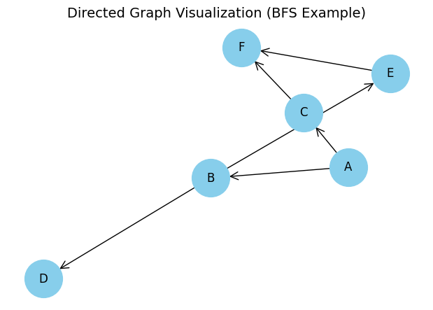

Depth-First Search (DFS)
Depth-First Search (DFS) is a fundamental graph traversal algorithm that explores as far as possible along each branch before backtracking. It starts at a selected node (often called the "root" node), explores as far as possible along each branch before backtracking and continuing to do so until all nodes have been visited.

Here's a high-level overview of how DFS works:
- Begin with a starting node and mark it as visited.
- Explore one of the unvisited neighbors of the current node.
- If all neighbors are visited, backtrack to the previous node and explore its unvisited neighbors.
- Repeat steps 2 and 3 until there are no unvisited nodes left.
- DFS can be implemented using either a recursive approach or an iterative approach using a stack.
graph = {
'A': ['B', 'C'],
'B': ['D', 'E'],
'C': ['F'],
'D': [],
'E': ['F'],
'F': []
}

def dfs(graph, start):
visited = set()
stack = [start]
while stack:
node = stack.pop()
if node not in visited:
print(node, end=' ')
visited.add(node)
stack.extend(reversed(graph[node]))

dfs(graph, 'A') # Output: A B D E F C

Depth-Limited Search (DLS)
Depth-Limited Search (DLS) is a variant of Depth-First Search (DFS) that restricts the depth of exploration to a predefined limit. This approach helps avoid infinite descent in cyclic or unbounded graphs by cutting off search paths beyond a certain depth.

How Depth-Limited Search Works
- Start at a selected node and mark it as visited.
- Explore one of the unvisited neighbors of the current node.
- Track the depth of each recursive call or stack entry.
- If the depth limit is reached, stop expanding that path.
- Backtrack to the previous node and explore other unvisited neighbors.
- Repeat until all paths within the depth limit are explored.

# Define the graph as an adjacency list
graph = {
'A': ['B', 'C'],
'B': ['D', 'E'],
'C': ['F'],
'D': [],
'E': ['F'],
'F': []
}
# Depth-Limited Search function
def dls(graph, node, goal, limit, depth=0, visited=None):
if visited is None:
visited = set()
print(f"Visiting: {node} at depth {depth}")
visited.add(node)
if node == goal:
print(f"Goal '{goal}' found at depth {depth}")
return True
if depth >= limit:
print(f"Depth limit reached at node {node}")
return False
for neighbor in graph[node]:
if neighbor not in visited:
found = dls(graph, neighbor, goal, limit, depth + 1, visited)
if found:
return True
return False

# Example usage
start_node = 'A'
goal_node = 'F'
depth_limit = 2

found = dls(graph, start_node, goal_node, depth_limit)
if not found:
print(f"Goal '{goal_node}' not found within depth limit {depth_limit}")

Iterative Deepening Depth-First Search (IDDFS)
Iterative Deepening Depth-First Search (IDDFS) is a hybrid search strategy that combines the space efficiency of Depth-First Search (DFS) with the completeness and optimality of Breadth-First Search (BFS). It is particularly useful when the depth of the goal node is unknown and memory is limited.

How IDDFS Works
- Start with a depth limit of 0.
- Perform Depth-Limited Search (DLS) up to the current limit.
- If the goal is not found, increment the depth limit and repeat DLS.
- Continue until the goal is found or the entire search space is exhausted.
This approach ensures that shallow goals are found quickly, while deeper goals are eventually reached without the memory overhead of BFS.

# Define the graph as an adjacency list
graph = {
'A': ['B', 'C'],
'B': ['D', 'E'],
'C': ['F'],
'D': [],
'E': ['F'],
'F': []
}

# Depth-Limited Search used by IDDFS
def dls(graph, node, goal, limit, depth=0, visited=None):
if visited is None:
visited = set()
print(f"Visiting: {node} at depth {depth}")
visited.add(node)
if node == goal:
print(f"Goal '{goal}' found at depth {depth}")
return True
if depth >= limit:
return False
for neighbor in graph[node]:
if neighbor not in visited:
found = dls(graph, neighbor, goal, limit, depth + 1, visited)
if found:
return True
return False

# Iterative Deepening DFS
def iddfs(graph, start, goal, max_depth):
for depth in range(max_depth + 1):
print(f"\nSearching at depth limit: {depth}")
visited = set()
if dls(graph, start, goal, depth, visited=visited):
print(f"Goal '{goal}' found within depth limit {depth}")
return True
print(f"Goal '{goal}' not found within max depth {max_depth}")
return False

# Example usage
start_node = 'A'
goal_node = 'F'
max_depth = 4

iddfs(graph, start_node, goal_node, max_depth)

Uniform-Cost Search (UCS)
Uniform-Cost Search (UCS) is a search algorithm that expands the node with the lowest cumulative cost from the start node, rather than the shallowest depth. It is a variant of Dijkstra’s algorithm and is optimal when path costs vary. Unlike DFS or BFS, UCS considers the actual cost to reach a node, making it suitable for weighted graphs where different paths may have different costs.

How UCS Works
- Start at the initial node and add it to a priority queue with cost 0.
- Select the node with the lowest path cost from the queue.
- Expand the node and add its neighbors to the queue with updated cumulative costs.
- Repeat until the goal node is selected for expansion.
- UCS guarantees finding the least-cost path to the goal if all costs are non-negative.

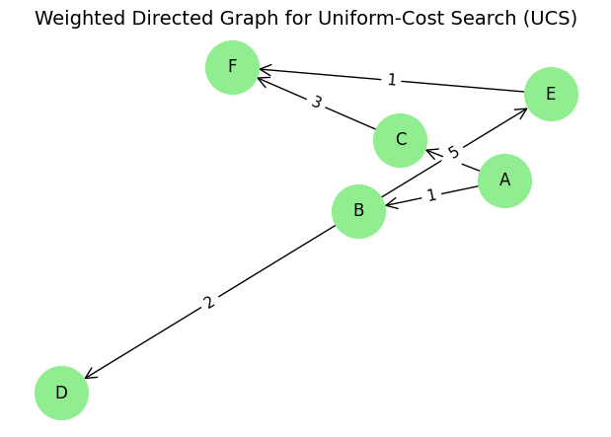
import heapq

# Define a weighted graph as an adjacency list
graph = {
'A': [('B', 1), ('C', 4)],
'B': [('D', 2), ('E', 5)],
'C': [('F', 3)],
'D': [],
'E': [('F', 1)],
'F': []
}

# UCS implementation
def ucs(graph, start, goal):
visited = set()
queue = [(0, start, [])] # (cost, current_node, path)

while queue:
cost, node, path = heapq.heappop(queue)

if node in visited:
continue

visited.add(node)
path = path + [node]
print(f"Visiting: {node} with cost: {cost}")
if node == goal:
print(f"Goal '{goal}' reached with total cost: {cost}")
print(f"Path: {' -> '.join(path)}")
return
for neighbor, edge_cost in graph[node]:
if neighbor not in visited:
heapq.heappush(queue, (cost + edge_cost, neighbor, path))

print(f"Goal '{goal}' not reachable from '{start}'")

# Example usage
start_node = 'A'
goal_node = 'F'

ucs(graph, start_node, goal_node)

Output:
Visiting: A with cost: 0
Visiting: B with cost: 1
Visiting: D with cost: 3
Visiting: C with cost: 4
Visiting: E with cost: 6
Visiting: F with cost: 7
Goal 'F' reached with total cost: 7
Path: A -> B -> E -> F

Lab Task
Implement the all uninformed searching algorithms for the given problem?

Graph Problem No. 1
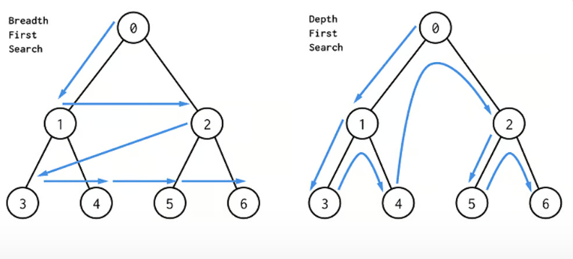

Graph Problem No. 2

